## Cesium, Inc. d/b/a Knowde F

Demo date: Jul 11, 2024  
Scoping start date: Jul 17, 2024

MSA Signature Date: Aug 20, 2024 - Needs updating  
Onboarding Kick Off Date: Aug 26, 2024 - Need Updating

[If Exists] Opt Out Date: Mar 1, 2025   
Go Live Date: Feb 7, 2024 - Needs Updating

GTM POC: Daniel  
Implementation POC: Royce

ERP: NS

Tax Integration: Avalara

### 

### Key people at Merchant

### Controller (Champion): Griffin Walker - griffin.walker@knowde.com

### Director of FP&A (Decision-Maker): Brian Young - [brian.young@knowde.com](mailto:brian.young@knowde.com)

* Head of Finance & Ops: Aleks Lyng - [aleks@knowde.com](mailto:aleks@knowde.com)
* Staff Accountant: Gracie Turk - gracie.turk@knowde.com

### 

| AE/ Implementation Notes Sections [Ops International Team to Ignore]   * Netsuite setup: * Sales order > Invoicing flow * Their e-commerce business is just invoices, with no sales orders but they are open to changing it -*phasing this part of the business out to focus solely on merchant* * Tax - uses Avalara and is wrapping up on the setup now * Payments (Mark as paid on tabs sync over) - Cash app is a pain point * Customer creation (pushed back as something that they should do). They asked if it's on our future roadmap * Netsuite customers have Salesforce details |
| --- |

### 

### Company summary

Organizes and digitizes product data for the chemical and ingredient industry. Was functioning as a marketplace, but recently changed scope to focus more on the digitization piece for suppliers and distributors.

Goals (North star)

Streamline invoicing and have Netsuite as source-of-truth. Consolidate rev rec within one platform. Leverage Tabs as a full A/R platform.

Salesforce to Netsuite integration and ability to pull in billing data for sales / CS teams to have visibility. Primary goal is to reduce the number of hours it takes to complete certain projects.

### Billing model

* Platform fees billed quarterly, biannually, and annually
* Also have professional services as a growing billing element - will be billed monthly

### Contract Processing Steps

**Please note that this merchant is very picky and will review every single contract, please ensure that there’s additional review and audit in place and that you’re following the instructions closely.**

1. Steps to process
   1. Each Item should be processed as its own Revenue Schedule. This is important to note.
      1. Do NOT have more than one billing item under the same revenue schedule.
      2. ***Please assign the revenue category to the item name, they should match 1:1. If there’s any questions or new revenue categories, please flag them.***

* 1. Description (Under the Knowde Services and Fees section), please confirm the following SKUs (even through the contract doesn’t say subscription, please add the word subscription)  
     ***Item name to match the list given below and Item description to match the BT name in the contract***
     1. Master Data Management Platform Subscription
     2. Customer Experience Application Subscription
     3. Knowde's Professional Services Support Hours
     4. PIM Solution
     5. White Label Solution
     6. White Label/PIM Solution
     7. Basic Storefront Solution

If the item name is not in the list above, slack ashni.

* 1. Discount (If there's any discounts, please prorated them based on the values of the individual subscription) - use the net BT (gross - discount).

Example:

Discount Amount = $30,000

| SKUs | Pre-discount Price | Amount to use in BTs |
| --- | --- | --- |
| Product A | $200,000 | $190,000 |
| Product B | $400,000 | $380,000 |

* 1. Dates

The contracts will have two different dates "Order Effective Dates" and "Subscription Dates".

Take Coast Southwest for example:

* Order Effective Dates: We read this signature dates as the Order Effective Dates and billing should go out upon signature (11/21/2024)
  + Pick the dates that are the latter between the two of the signature dates.
* Subscription Dates: This is the date to use for Revenue Recognition (12/2/2024)
* Example processed here: <https://garage.tabsplatform.com/prod/contracts/d6cf5ee9-6870-40d3-92a1-6de579e454bf/terms/revenue>

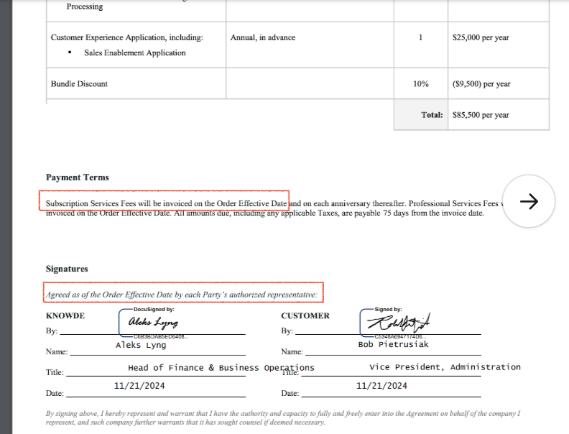

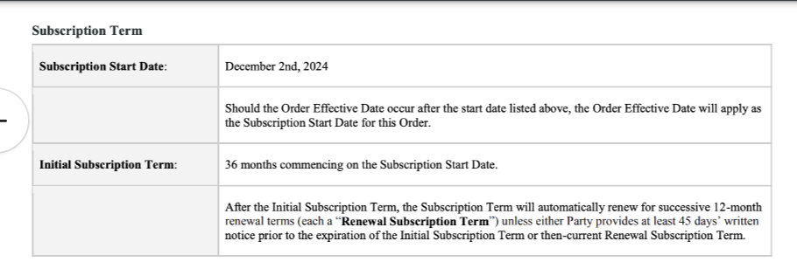

* 1. Subscription Term
     1. Follow the contract language
     2. If None Listed, please check with your manager or implementation manager
  2. Default Net Payment Terms
     1. If None, Ops Default is 0
  3. Default Billing Frequency
     1. If None Listed, Ops Default is Monthly

Integration Items Processing (if necessary)

* Integration items will be the same as the item name

| Description in Contract | Integration Items |
| --- | --- |
| Basic Storefront & White Label Bundle | TBD |
| First Year Signing Credit |  |
| Year 1 Phase 1 Subscription Fee |  |
| Year 1 Phase 2 Subscription Fee |  |
| Implementation Fee |  |

### Events Processing (if necessary)

Post Processing Communications (if necessary)

* Does the Ops Team need to notify anyone on the team re: completion of processing batches in Implementation or Active phase?
* Who needs to be notified and when?
  + Example:
    - Who: Customer Success [Azmat Aziz] needs to be notified
    - Where: Messari internal merchant channel
    - When: contracts are processed [Merchant Phase: Active]

### Customer Information

* Any important information on specifics customers of this merchant
  + Special memo’s certain invoices require
  + Invoice changes due to merchant/customer relationship

### Feature Requests

* Salesforce Integration
  + What is it: Push invoice status back to SFDC
  + Why it's important: Want CSMs to have insight into customer status
  + Urgency: Q1

### Rewatch Calls

* Dec 23, 2023: [First Call](https://tabs.rewatch.com/video/0o3uqtpvpe8swtku-griffin-and-rebecca-schwartz-tabs-december-21-2023):
* April 18: [Netsuite Scoping](https://tabs.rewatch.com/video/vb2ka779wqzd0k5b-knowde-tabs-netsuite-scoping-april-18-2024)
* July 10: [Prep for Custom Demo](https://tabs.rewatch.com/autocomplete/redirect_search?terms%5B%5D=Griffin&url=%252Fvideo%252Fh3egyqunsuuqag9x-griffin-rebecca-quick-sync-july-10-2024)
* July 11: [Custom Demo](https://tabs.rewatch.com/video/oupeu63smn9h7537-tabs-knowde-demo-july-11-2024)
* July 17: [Proposal Review (Rev Rec Historical Convo)](https://tabs.rewatch.com/video/lofdaicdwj54fubr-tabs-knowde-proposal-review-july-17-2024)